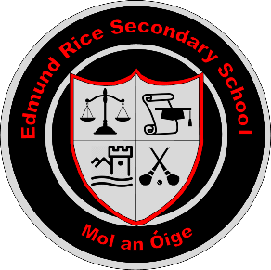
Edmund Rice Secondary School
ANNUAL ADMISSION NOTICE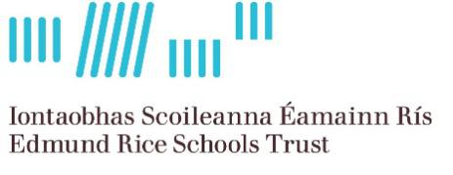

in respect of admissions to the 2024 – 2025 school year
Admission Policy and Application Form
A copy of the school’s Admission Policy and the Application Form for Admission for the 2024 – 2025 is available as follows:
To download from October 9th at: www.erss.ie
On request: By emailing info@erss.ie or writing to: Edmund Rice Secondary School, Mount St. Nicholas, Carrick-on-Suir, Co. Tipperary, E32 P039
PART 1 - Admissions to the 2024-2025 school year
Application and Decision Dates for admission to 2024 - 2025
The following are the dates applicable for admission to First Year
The school will commence accepting applications for admission on: | Monday October 9th
The school shall cease accepting applications for admission on: | Friday October 27th
The date by which applicants will be notified of the decision on their application is: | Friday November 17th
The period within which applicants must confirm acceptance of an offer of admission is: | Friday December 1st
*Failure to accept an offer within the prescribed period above may result in the offer being withdrawn
Note: the school will consider and issue decisions on late applications in accordance with the school’s admission policy.
Number of places being made available in 2024/2025
The number of places being made available in first year is: | 60

