What is a Classroom-Based Assessment (CBA)?
How are the CBAs assessed?
Your child’s teacher will assess their CBA using nationally agreed standards, these are called ‘features of quality’.
After the CBA, there is a meeting with all the teachers of that subject. Here, teachers share and discuss samples of their assessments of student work. A descriptor is then awarded and reported to the student.
All CBAs are assessed at Common Level.
Classroom-Based Assessments are central to assessment in all subjects and short courses.
They provide your child with opportunities to demonstrate their learning and skills in ways not always possible in a formal examination.
The CBA is similar to the formative assessment that occurs every day in class.

What are the descriptors?
Short Course CBAs
When are the CBAs?
Your child will do two CBAs in each subject. One in second year and another in third year (except in Irish, where both CBAs are in third year).
Short courses will report on one CBA.
What does my child have to do?
Each CBA takes on a variety of forms across subjects and short courses, for example
- project and oral language tasks
- investigations
- practical or design and make tasks
- field studies
- artistic performances
My child is doing a Level 2 Learning Programme (L2LPs). Can they do a CBA?
Yes. CBAs form part of the assessment of L2LPs short courses.
In addition, some students taking L2LPs may also be capable of undertaking a CBA in a Level 3 subject and/or short course. This choice can be discussed with the school.
Your child’s CBA will be awarded one of the following descriptors
- Exceptional
- Above expectations
- In line with expectations
- Yet to meet expectations
This descriptor will appear on your child’s Junior Cycle Profile of Achievement (JCPA) alongside their other recorded achievements.
How long does my child have to complete a CBA?
The majority of CBAs are in a three-week time frame. Some CBAs take place over a longer period of time e.g. Business Studies, Home Economics, Visual Art
What if my child is absent?
Individual circumstances, where they arise (e.g. absence), will be dealt with by the school.
How can I help my child?
Advise your child that CBAs are part of normal classroom practice.
Talk with your child about how they are getting on with their CBAs.
Support your child to value their CBAs as part of the junior cycle learning journey.

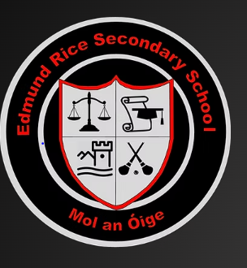

Examples of CBAs:
Information on Classroom-Based Assessments
for parents and guardians
English CBA 1: Oral Communication History CBA 1: The Past in my Place
Mathematics CBA 2: Statistical Investigation
Science CBA 2: Science in Society Investigation

Where can I find out more? www.curriculumonline.ie

