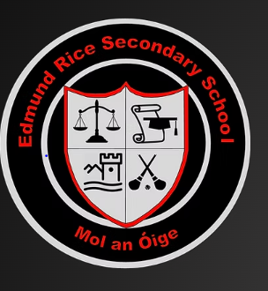
My CBAs

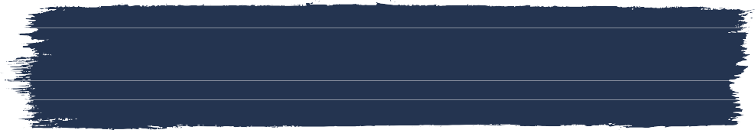
When do CBas take place?
CBA 1 is in 2nd year and CBA 2 is in 3rd year (expect in Irish - both in 3rd year).
Short courses have one CBA and it be can be completed in 2nd or 3rd year.

CBAs are an opportunity for me to demonstrate my learning in a variety of ways, for example; project and oral language tasks,
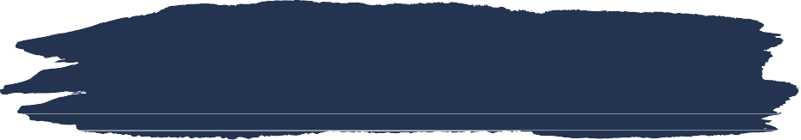
investigations, practical or design and make tasks, field studies, and artistic performances.
What is a CBA?
CBAs are central to assessment in all my subjects and short courses.


How long do I have?
It depends on the subject. Most CBAs are to be completed in three weeks. But some subjects
take longer.

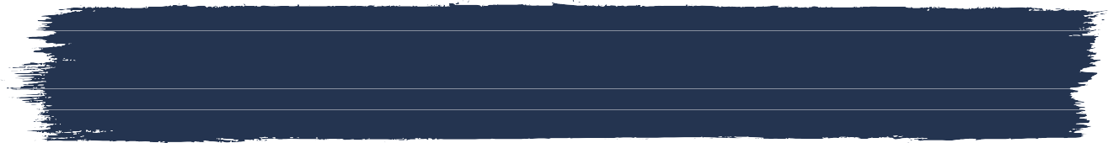
When do I get my CBA descriptor?


Some CBA's can be done in a group. If it is a group project, I will always be assessed
Can I do my cba in a group?
individually.


How will i know what to do?
CBAs build on the everyday teaching, learning and assessment that takes place in the classroom.
my teacher will discuss the success criteria with me so that I have a clear understanding of what I need to do.





all the subject teachers then meet together to discuss the CBA work.
How is my CBA assessed?
My teacher will assess my work using the
'features of Quality'.
Then my teacher awards the final descriptor.
My teacher will share my descriptor with me after they have had their meeting with the other teachers.
My final CBA descriptors will be on my JCPA.


The 'features of quality' are the criteria that will be used by teachers to assess students' work. Each subject/short course CBA has unique 'features of
quality'.


CBAs have four level descriptors of achievement:
- Exceptional
- above expectations
- In line with expectations
- yet to meet expectations

