TRANSITION YEAR
2024/2025
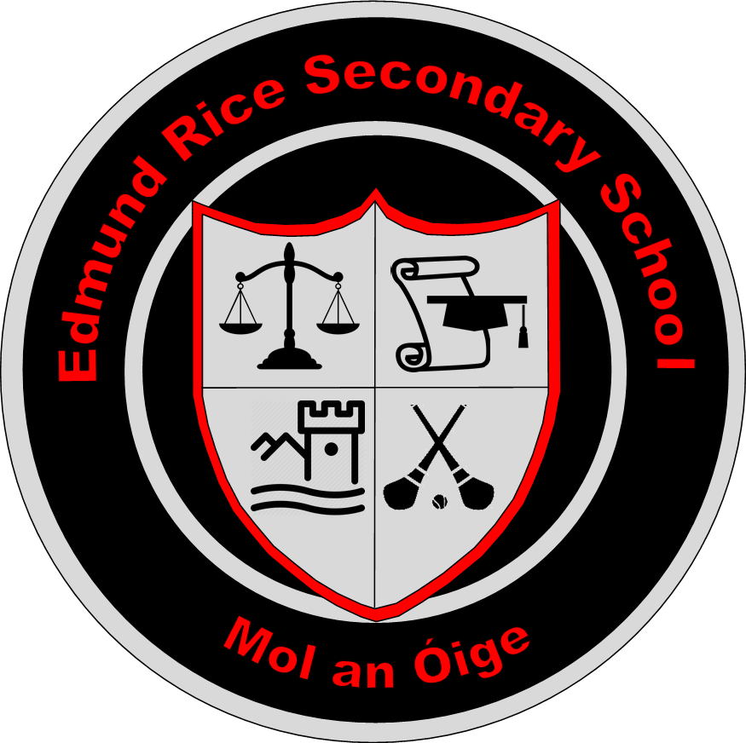

ERSS Carrick-on-Suir
Carrick-on-Suir
Co. Tipperary

(Currently under review to come in line with New Transition Year Programme Statement in September 2025)

School Mission Statement:

"To provide a caring Christian community which celebrates effort and talent in an environment of hope and happiness"

Our mission statement permeates every aspect of school life. It reflects the vision of the Edmund Rice Trust in promoting full personal and social development of each student and striving to create an atmosphere where teaching and learning can excel. The creation of a safe and positive learning environment is at the heart of what we do. We want our students to achieve their academic potential and to leave the school with a skill set which prepares them for an ever-changing world.

Transition Year here at CBS is optional. Information on the aims and content of the year is made available to students and parents early in the 2nd term of third year. Those interested in availing of the programme are asked to fill out an application form. These applications are then assessed at a full staff meeting and successful applicants are informed and offered a place in the year.

Aims & Objectives of the Programme

Transition Year in this school provides an excellent foundation for the Leaving Certificate Cycle. A considerable portion of the school week in Transition Year is allocated to aspects of core Leaving Certificate subjects.

Aims of the Programme Include:

- Education for maturity with an emphasis on social awareness
- Education through experience of adult and working life as a basis for personal development and maturity.
- Promotion of general, technical and academic skills with emphasis on interdisciplinary and self-directed learning.

This school has high expectations of students participating in transition Year. Our objectives for the pupils include the following:

- Acquiring a solid basis for the Leaving Certificate Programme in terms of actual Leaving Certificate subjects (e.g., Higher Maths) and a sample of some of the content of other subjects.
- The potential to improve a pupil’s prospective grade in the Leaving Certificate. An N.C.C.A survey suggests that students who opt for T.Y tend to score better points in the Leaving Certificate Examination.
- To encourage students to take personal responsibility for their own learning in areas such as research and project work. This type of work is typical of what is required from students at third level.
- Through opportunities such as work experience and Enterprise students can develop specific life skills and get hands on experience of the world of work and enterprise.
- Through community involvement in projects such as Meals on Wheels and Gaisce pupils can gain a greater awareness and thus become more able and responsible citizens.
- The pupil’s attitude towards the school as a place of learning becomes more positive due to the variety on offer in the Transition Year curriculum.

Role of Management:

The principal of the school and management have primary responsibility for the implementation of the Transition Year Programme in ERSS Carrick-on-Suir.

Transition Year Team:

Coordinator: Mr Foran
Tutors: Ms Flynn & Ms Kirwan

Core Team
TY Coordinator & Year Head | Mr Foran
Tutors | Ms Flynn & Ms Kirwan
Management | Ms Gleeson & Ms Barry
PR Representative | Mr Shaw

Transition Year Curriculum

Core Subjects
- Irish
- English / Media/Communications
- Maths
- History
- Business
- Geography
- French
- Religion
- Sciences
- Home Economics

Other Subjects
- Construction Studies
- DCG
- Art
- Swimming
- Work Applications
- Enterprise

As can be seen from the above range of subjects T.Y provides a sound basis for the Leaving Certificate Examinations as well as giving the students a wider experience of other less traditional subject areas. Having completed the TY Programme students should be better able to make some informed choices for the Leaving Certificate.

As well as regular homework pupils of T.Y are assigned project work which demands a different set of learning and presentation skills. While the course is free from the stressful demands of the Leaving Certificate students are expected to produce a high standard of work and show a willingness to get involved in various class related activities.

Examples of ICT Resources for TYP Teachers
Beneficial from methodological, subject content and support perspectives (list not exhaustive)
Methodological | Subject Specific | Support
http://www.pdsttechnologyineducation.ie/en  www.puzzlemaker.com  http://www.quizlet.com http://www.padlet.com  http://www.mentimeter.com | www.pdst.ie/TY  www.skoool.ie  www.scoilnet.ie | www.education.ie  www.pdst.ie/support  www.ncca.ie
Other relevant websites:

www.localenterprise.ie
www.worldwiseschools.ie
www.youthconnect.ie
www.goal.ie
www.concern.ie
www.svp.ie
www.careersportal.ie
www.equality.ie
www.eoy.tv
www.youngsocialinnovtors.ie
www.sdpi.ie
www.studententerprise.ie

Assessment in Transition Year
Methods of assessment in Transition Year varied. Individual subject and module teachers plan their assessment methods annually to best complement the learning experience encountered by students in respective subject areas. An overview of the assessment methodologies practiced in Transition Year includes the following:
- Written assessment
- Oral assessment
- Aural assessment
- Report Writing
- Skills Development analysis
- Practical assessment
- Rating Scales
- Skills Recording
- Transition Year Journal/ Diary
- Workbook / Log completion
- Homework assessed regularly by subject and module teachers
- Project based assessment – written and I.C.T. based.
- Paired and Group work assessment
- Performance based assessment
- Creative project-based assessment

Students are informed by teachers of the different assessments that will form part of their overall end of year performance rating and resulting certification.
Parents are informed of individual student progress at Christmas and Summer with formal reports sent home from school. These reports include details of marks and grades achieved in each subject/ module as well as a personalized comment from each teacher.

Twice during the school year, at Christmas and the end of the school year pupils are assessed formally using house examinations. Their level of achievement is graded under each of these headings. The reports are my visible to parents online on VSware using their personal log in details. There is also one parent/teacher meeting usually held early in term 3.

Each pupil completes a diary/log which charts his progress throughout the year. Interviews are also conducted as part of the assessment process and certificates are presented based on the following three categories: Pass Merit Distinction

An awards night brings the TY year to an end. The class are very much involved in the preparations for the night to which parents are invited. One of the students takes on the role of MC and each student gives a brief account of some aspect of the TY Programme. Also on display are various projects, photographs and wall charts which reflect work in various subjects as well as activities such as outings and trips. The preparation for this event involves speech writing, communication skills and public speaking. Special guests on these nights have included an ambassador, sports stars and journalists. Recently we have invited a number of former T.Y. students to share their journey since leaving ERSS (Formerly CBS Carrick-on-Suir).

A Portfolio of Certificates is presented to the students on the night. Also included in the portfolio are certificates of completion in other areas such as computers skills, Home Economics, F.A.I Coaching and ECDL. Those who have completed the Gaisce Challenge also receive their medals and certificates.

Textbooks
Textbooks and other related materials are decided by the different subject teachers and are offered on the Loan Scheme to the students.

Work Experience
Work experience now takes place every Wednesday over the entire school year.

- Each Pupil sources his own work experience / work area. We encourage students to get a variety of placements in order to acquire a broad range of experiences.
- Career guidance teacher speaks to pupils on preparation for work:

Employers Expectations
Importance of Punctuality
Discretion etc.
- Contact is made with each pupil / employer either by visit or telephone.
- Employers fill out an assessment of each pupil.
- Each student keeps a log of work and is asked to complete an assessment / evaluation afterwards.
- Career Guidance teacher carries out follow up work

Work Experience allows pupils to identify a future career and to decide if a particular career is suitable for them. This invaluable experience feeds back into better subject choices if a student decides on a career because of the experience gained during T.Y. If pupils are more definite about the decisions which they make they will be more motivated to work towards the goals which they have set for themselves.

Community Involvement
An integral part of the TY programme in this school has been community involvement.

- Visitations to the local Day Care Centre and Greenhill Nursing will hopefully take place this academic year however this is proving difficult due to Covid-19 and restrictions to these centres at this time.
- This year we hope to link in with Carrick-on-Suir Lions Club to carry out a group litter pick along the Blueway and surrounding area. This community involvement helps raise awareness among the students of the value of volunteerism and a range of issues relating the biodiversity on out local area.
- We have an ongoing link with our feeder schools in Carrick-on-Suir. Our Transition year students will visit these schools throughout the year to read stories and interreact with the primary school students.

Gaisce Awards
Taken at Bronze level by most of the year
Students are required to complete challenges in four areas:
- Community Involvement
- Personal Skill
- Physical Recreation
- Adventure Journey
The Venture involves hiking in Graiguenamanagh with an overnight stay. This will be combined with a kayaking activity.

Swim Sean Kelly Sport Centre
Duration: All Year: September – May
Venue: Sean Kelly Sports Complex
2 class periods per week. Pupils avail of swimming pool facilities
All these modules and activities fit readily into the main aims of the Transition Year Programme. The modules and activities help to promote:

- Personal and Social Development
- Develops initiative and self confidence
- Broadens the educational experience
- Develops a greater range of talents and skills

Additional Learning Experiences

Speakers:
Fitness Nutrition Talk and Workshop – Ritchie Kennedy (Fitness Freak)
Army/Defence Forces speaker – Eoin McNamara
Manual Handling Course – Padraig Ryan
RSA Road Safety – Fiona Kavanagh
SETU – Business Dept
Team building – Paul Curran (Allstar Coaching)
Carrick-on-Suir Lions Club - Brian White
Comedy Workshop – Bernard Casey
Acting Workshop – Alan Devine
Self Defence Workshop - Close Encounters – Ken Cavanagh
Bodhran Making Workshop – Michael Vignoles
Aware Workshops - Eileen Kennedy
First Aid Training – Red Cross

Trips/Events:
National Ploughing Match – Ratheniska
Ormond Castle – Carrick-on-Suir
Cinema Trip Dungarvan SGC as Gaeilge – Roise & Frank
Ice Skating & Cinema – Winterval Waterford
Barcelona
Tayto Park Business Trip

Additional Experiences:
Safe Pass Course (For student who require this for work experience)
Day Care Centre/ Nursing Home – (Restricted due to Covid)
Community Involvement – Link with local primary school – Soccer Coaching
RCSI - Mini Med & Mini Physio
Gaisce Award - Bronze
Interview Preparation
Placement with Companies/ Colleges
Drugs Presentation
Internet Safety
Enterprise Competitions
Build a Bank
Homework Club
European Ambassador Schools Programme
Comhairle na nOg
Career Information Days
Young SVP
Pumkin Carving

Induction for new Students and Parents

Students
Students are briefed at an early stage (during 3rd year) on the programme requirements as set out by ERSS Carrick-on-Suir in keeping with the Transition Year Programme Guidelines for Schools 1995.

Parents
“Schools need to be proactive in engaging parents in all aspects of TY” (Jeffers, 2007).

Information night is held for Third Year parents early in the second term, where they have an opportunity to hear what is involved in Transition Year and are given an opportunity to ask questions.

- Parents night
- Information on school website and TY Twitter page
- Promotional material- Brochure
- Why do TY???

Recording Procedures

Transition Year students record all details in relation to events and assignments in their homework / TY diary

Attendance is recorded in the school online facility VSware.
Results are recorded on VSware twice during the school year.

Transition Year Circulars

M1/00 - The transition year programme
19/03 - Standardisation of school year
17/02 - Programme co-ordinator posts in voluntary secondary schools
O0/55/2013 - Revised arrangements 2013/2014 – Transition Year Certificates.
http://www.education.ie/en/Circulars-and-Forms/

